Managing Conflict in Workplace: A Study on …………………………………………………………………………….
  - An Assignment Project of Conflict & Crisis Management
[Type the abstract of the document here. The abstract is typically a short summary of the contents of the document. Type the abstract of the document here. The abstract is typically a short summary of the contents of the document.]
Submitted by:
Name: ………………………….……………..
Reg. No: Reg. No:
Submitted to:
B.K.Dhar
Assistant Professor, Faculty of Business Administration,
University of Science & Technology Chittagong
Date of Submission:
… August, 2013

Managing Conflict in Workplace: A Study on …………………………………………………………………………….
  - An Assignment Project of Conflict & Crisis Management

Specific Recommendation
• • •
- Need to increase …………….
- Can enhance ……………………………………………………………….
- It will be better to ………………………………………………………………………
- Etc.

About the Organization (not more than 100 words)
……………………………………………………………………………………………………………………………………………….
……………………………………………………………………………………………………………………………………………….
……………………………………………………………………………………………………………………………………………….
……………………………………………………………………………………………………………………………………………….

Problem of the Study (not more than 50 words)
...……………………………………………………………………………………………………………………………………………….
……………………………………………………………………………………………………………………………………………….

Finding of the study (not more than 50 words)
Based on the questioner that has been attached in the Appendix, the study has found that the company ……………………………………………………………………………………………………………………………………………….
……………………………………………………………………………………………………………………………………………….
Appendix:
Table 1: Managing conflict at work: self-report for managers
(Please tick one box only in each row)
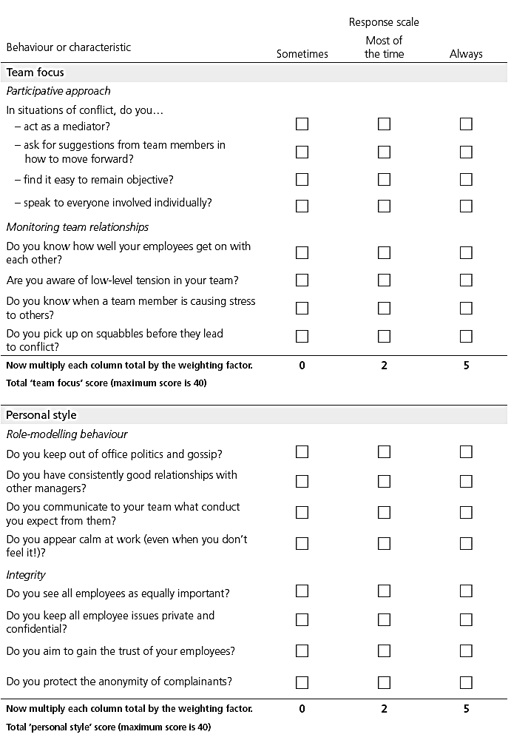

Table 2: Managing conflict at work: self-report for managers (continued)
(Please tick one box only in each row)
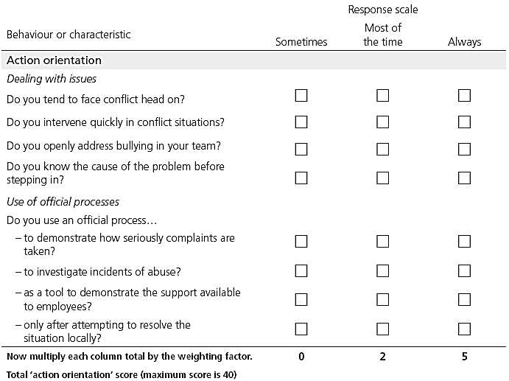

Scoring Method:

Score | Recommendation
0-14 | Development Need
14-28 | Reasonable
28-40 | Effective

